Write the pseudo-code or draw the flowchart of a program that reads the values for the three sides x, y, and z of a triangle, and then calculates its area. The area is calculated as follows: 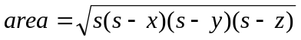
where s is 